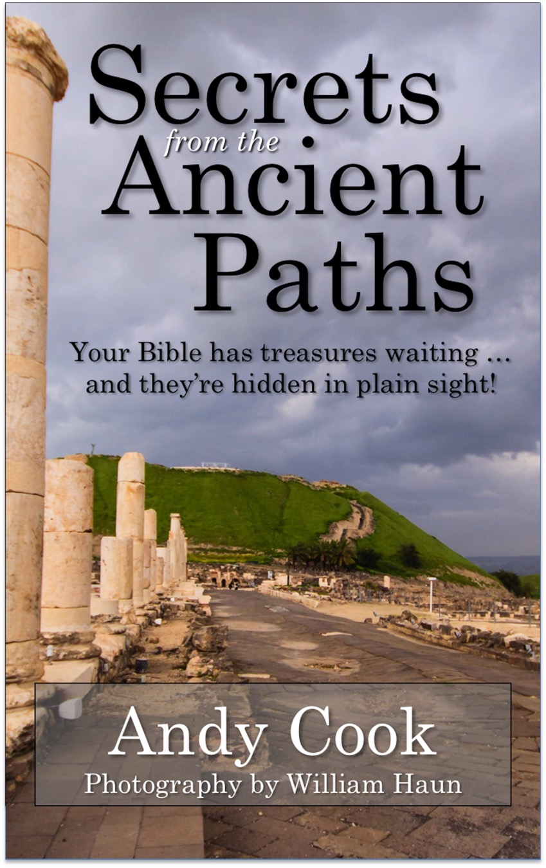

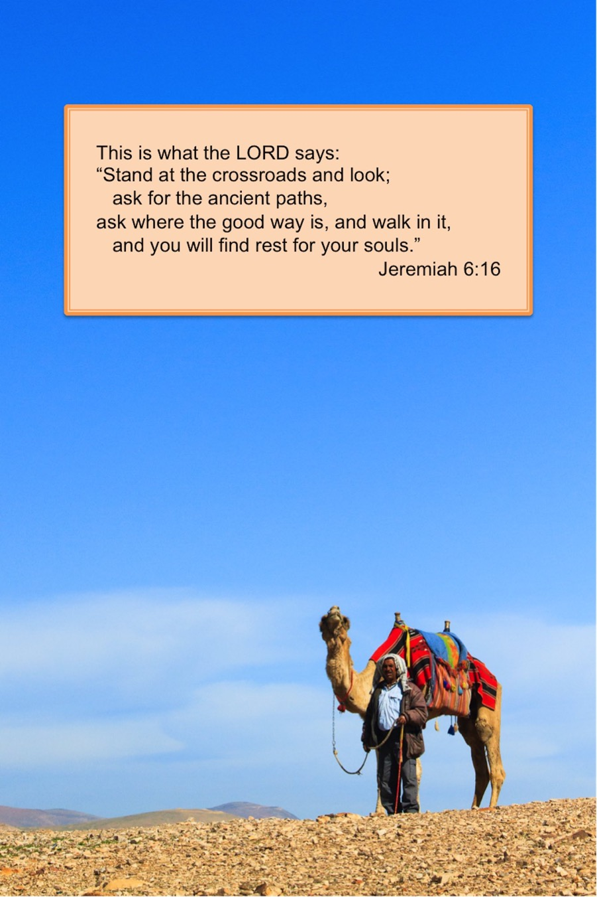

Secrets from the Ancient Paths
© 2013 by Andy Cook

Originally published as a hardback book by Kregel Publications, this electronic version is released by Experience Israel Now, Inc., 164 Old South Way, Fort Valley, GA, 31030. Hardback copies are available at experienceisraelnow.com or through The Friends of Israel Gospel Ministry, Inc. , foi.org.
All rights reserved. No part of this book may be reproduced, stored in a retrieval system, or transmitted in any form or by any means—electronic, mechanical, photocopy, recording, or otherwise—without written permission of the publisher, except for brief quotations in printed reviews. For inquiries, info@experienceisraelnow.com.
All Scripture quotations are taken from the Holy Bible, New International Version®, NIV®. Copyright © 1973, 1978, 1984 by Biblica, Inc.TM Used by permission of Zondervan. All rights reserved worldwide. www.zondervan.com
Scripture quotations marked nasb are from the New American Standard Bible®. Copyright © 1960, 1962, 1963, 1968, 1971, 1972, 1973, 1975, 1977, 1995 by The Lockman Foundation. Used by permission. www.Lockman.org.
This eBook cannot be converted to other electronic formats, except for personal use, and in all cases copyright or other proprietary notices may not modified or obscured. This eBook is protected by the copyright laws of the United States and by international treaties.

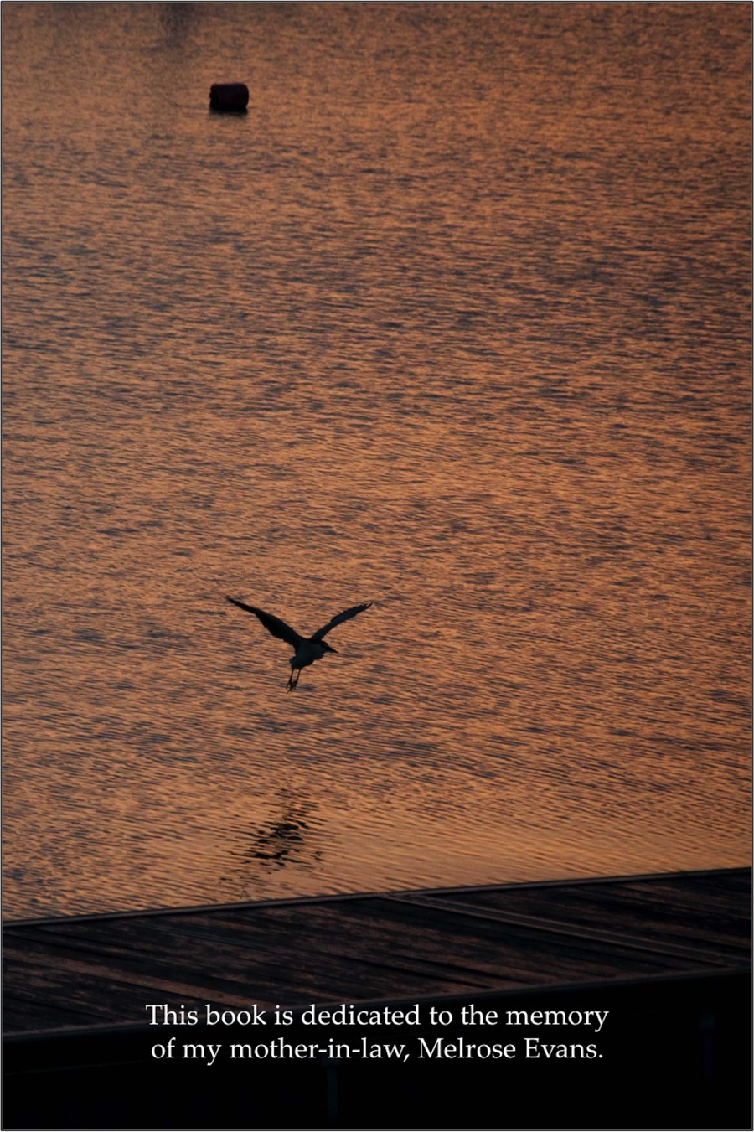

Table of Contents
Acknowledgments
Hidden in Plain Sight
The Parable of the Five Selfish Virgins
Clean Hands . . . and a Pure Heart
Closer Than You’d Think
No Lone Rangers Allowed
Where the Giants Fall
There Is No Free Pass
Only a Fool . . .
Written in the Dust
The Second Chance
Golgotha’s Resignations
All In
Storming the Gates of Hades
All Things for Good
About the Author
Photo Index
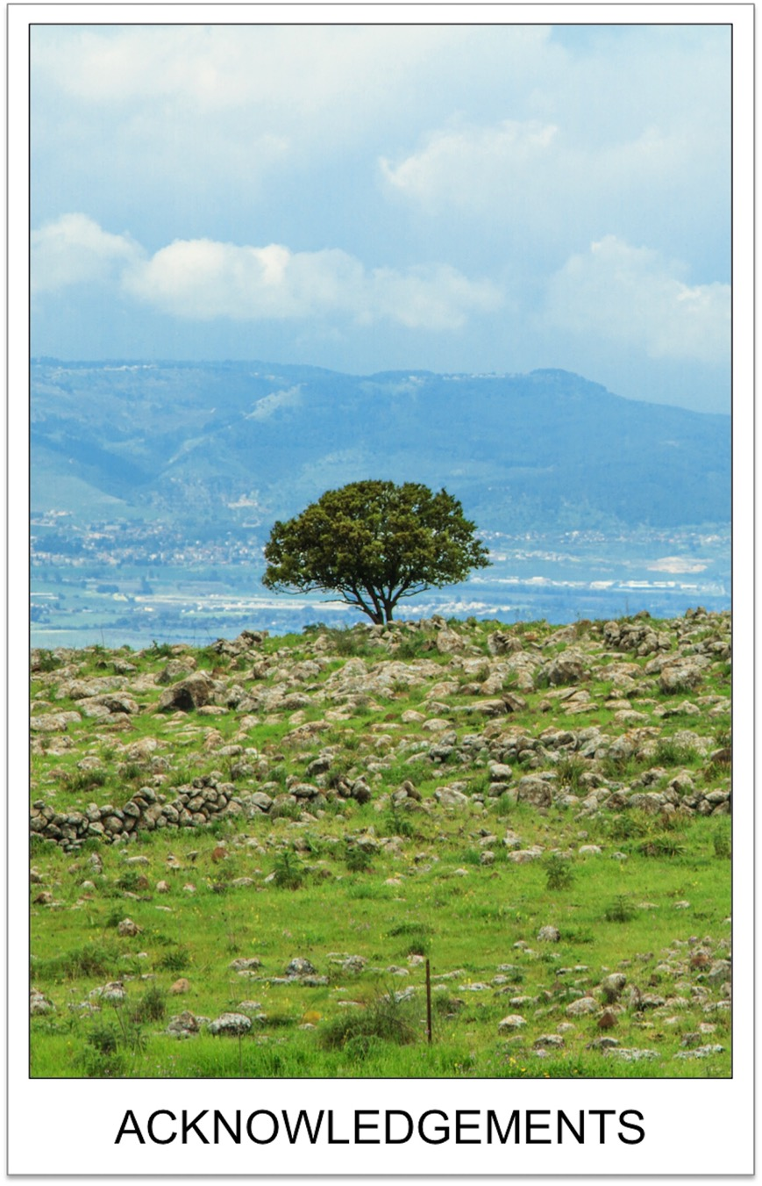

Many years ago, a professor at my seminary unfolded the Bible like no one had ever done for me before. Dr. Richard Spencer took the land of Israel, the academics of New Testament study, and the familiar stories of Jesus and the early church, and produced lectures that held us spellbound. There were mysteries being solved in that class, and we couldn’t get enough.

On one occasion, he mistakenly scheduled a final exam one class-day early, which meant our semester ended before time was officially up. Under normal conditions, such a day would be treated as a surprise holiday. In seminary, we might have even called it a gift from God! But this class was different. Out of a hope that he might show up anyway, I went to our classroom at our scheduled class time.
The room was packed. All of us wanted to know the secrets from the ancient paths. And, much to our delight, Dr. Spencer came and gave us another hour of insight. What this man was sharing was so intriguing, it didn’t really matter if the grades were set and the course was completed. If there was a chance he might teach again, we’d be there. In three years, I sat under his teaching as often as possible. He was the first to show me that there was much to learn from the land of the Bible, and he created in me a passion to walk the ancient paths myself.
Since that time, I’ve met many other great teachers, but none better than Ray Vander Laan. Visit Israel, and you’ll tour many ruins. Visit Israel with Ray, and he’ll make the rocks talk. My 2009 trip to Israel with him turned out to be a life-changing experience. Someone once asked me, “What exactly changed?” Part of me wanted to ask, “What didn’t change?” But instead I replied, “The passion. He showed me what passion for following Jesus looked like.”
And I wanted that passion. We live in an age when information is available everywhere. Passion, however, is a rare commodity. Passion for following our rabbi is even rarer. I am a better follower of Jesus because I’ve had the chance to walk with Ray Vander Laan.
For all my teachers, and for the volumes of books and resources they have directed my way, I am thankful. My words in this book are, in part, little more than a mixture of their words.
I am also grateful to Israel’s Ministry of Tourism and the Christian Television Network for their partnership in allowing me to teach on location at so many biblical sites. God has allowed us to do a great work together, and I am humbled.
I owe a great debt to the people of Shirley Hills Baptist Church in Warner Robins, Georgia. They have supported my dreams, my travels, my writing, and my family far more than I could have ever expected.
I am also grateful to the Board of Directors at Experience Israel Now, Inc. What an honor to work with such a talented group!
And closest to my heart is my family. Our family tree is grounded in a long history of men and women who followed Jesus with an “all-in” attitude. My parents handed that legacy to me, one patient day at a time.
My wife, Melody, is the only woman I’ve ever loved, and I would not be following my dream if she hadn’t followed me. Over the past thirty-plus years, we’ve grown up with three incredible girls—Summer, Melinda, and Courtney—and added two sons in law. Now we’re grandparents, and yes, there are photos. Life is good, for we’re all on the journey together.
Finally, I am thankful for you. If you’ve chosen this book, you’re after the same passion I’m after. In a sense, you’re standing at the crossroads, asking for the right way. Thank you for asking. You’ve made me a better traveler, for nothing energizes me more than telling the story to those who want to hear it.
Let’s take the good way together.
Rest for our souls is waiting.
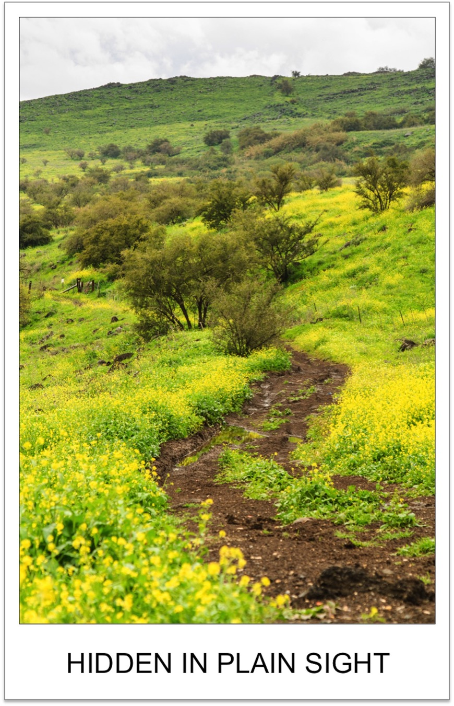

A friend of mine once served in a covert corner of the American military forces. He was part of the “Special Ops” (or Special Operations) that trained for and carried out secret missions around the world.
This was clandestine work. Secret stuff. They always faced great danger as they worked. As a result, they worked very hard not to be discovered.
“We had a problem,” he once told me. “How do you hide a huge airplane filled with Special Ops forces and all their equipment?”
The answer? You hide them in plain sight. If you need to hide an airplane, hide it among other airplanes . . . at an airport. If you need to hide highly trained troops, make them look like the other people at an airport. If there are already hundreds of passengers, airport workers, and delivery personnel swarming over the property, simply blend in as passengers, airport workers, or delivery workers.
Did it work? “Every time,” my friend laughed. “We were in, we were out, and they never knew we were there.”
The Bible has a few secrets, too. Hidden among all the words, and all the stories, are a handful of details that can transform even the most familiar passages of Scripture. In a sense, the information that is there wasn’t hidden at all. The details are very much in plain sight. And yet most people miss them. Since most of us don’t live in the land of the Bible, we miss the insight the land can give us. Since most Christians aren’t Jewish, we miss the impact of our incredible Jewish heritage. And frankly, since most of us aren’t as committed students of the text as the first followers of Jesus were, we miss much of what is “hidden” from us, even though the words are right before our eyes. The full impact of the Bible’s words might as well be on a covert mission, slipping into our times of Bible study, and slipping out, unnoticed and undiscovered.
It’s time to discover those secrets.
Take the day when Jesus said this:
Come to me, all you who are weary and burdened, and I will give you rest. Take my yoke upon you and learn from me, for I am gentle and humble in heart, and you will find rest for your souls. (Matthew 11:28–29)
Familiar words? Of course! Most followers of Christ would recognize the words as some of the most comforting you’d ever want to hear. But there is also something else here. There is more here than meets the eye. And those who heard Jesus speak the words in person knew the secret.
In that case, they knew Jesus was quoting one of the prophets. Like Jesus, most of the people in his audience that day had already memorized Jeremiah’s words.
This is what the Lord says:
“Stand at the crossroads and look;
ask for the ancient paths,
ask where the good way is, and walk in it,
and you will find rest for your souls. (Jeremiah 6:16)
“. . . rest for your souls.” Jeremiah had held it out like a tantalizing offer. It’s as if he had said, “If you’ll look for it, you can have it. If you’ll ask for it, it will be given to you! So when you come to the crossroads—when you come to a place of decision making—stop and ask for help. The right path is there. It’s been there all along. It’s an ancient path. Walk here, and you shall find rest for the deepest part of you. Rest for your souls.”
Note that Jeremiah said these words weren’t his words. This message was from God. I like to picture a wild-eyed prophet making sure his audience got the point. “THIS . . . is what the Lord says!”
Unfortunately, many in Jeremiah’s generation missed the point. They missed the ancient path. Jeremiah’s generation found tragedy and hardship, and much of it had come from their own poor choices. Like us, they had moments that served as “crossroads.” All too often, they rushed forward without asking for guidance. They made far too many choices without regard to God’s instructions. They ignored the words that could have saved them heartache, destruction, and exile.
As a result, they missed the rest for the soul that could have come from following the ancient paths. The words were in plain view for them, as well as us. But because they didn’t consider them, the words remained “hidden.” The good way, the good path, was empty.
Jesus began his ministry with a simple invitation for those who would be his disciples. “Walk with me,” he said. “Follow me.” There were many trying to decide if they should follow. To those who would listen, he said,
Come to me, all you who are weary and burdened, and I will give you rest. Take my yoke upon you and learn from me, for I am gentle and humble in heart, and you will find rest for your souls. (Matthew 11:28–29)
Some were old enough to have become jaded to religious offers of peace. Some were worn down by the difficulty of keeping all the rules God required of them. Some were just tired. Fatigued. Ready to quit.
“Come with me,” Jesus seemed to be saying. “I’ll show you the way. Remember what Jeremiah offered? I’ll show you the ancient path. I’ll show you the good way. I’ll give you rest for your souls. I’ll give you what you’ve always wanted. I’ll satisfy that longing that has long existed in the deepest part of who you are. I’ll give you rest . . . rest for your soul.”
It was an echo of what Jeremiah had said were God’s words from long ago. Too many people had missed the right path for far too long. So Jesus came, and he had said he’d come to show the way. Actually, Jesus said he was the way. “I am the way,” he said in John 14:6. In the language of the New Testament, “way” is also “path.”
I am the path . . .
From time to time, all of us stand at the crossroads. Every day, we have choices to make. Consequences will follow those choices as surely as gravity causes apples to fall from trees. Make the right choice, and we’ll enjoy the consequences. Make the wrong choice, and we’ll regret the consequences.
So ask where the good way is. Listen to the offer again.
“Come to me,” Jesus said, “and you will find rest for your souls.”
Jesus is the right path. The right way. So follow Jesus. Pause at the crossroads every day. Ask him for the right way, the good way . . . the ancient way. If you walk in that way, you’ll find the best life you’ve ever known. It will have trouble, hardship, joy, and celebration. And yet there will be purpose all along the way, and a quiet confidence that you’ve found the right way.
Call it a deep satisfaction. Call it a peace that passes all understanding. Or if you like, use an ancient phrase. Call it “rest for your soul.”
So, are there really “secrets” to be found along the ancient paths? Sure there are. However, once you find them, you’ll see that these “secrets” were “hidden” in plain sight. In a sense, the dust of time and culture has covered them up. What we’ll seek to do is travel back in time to the original setting. We will need to remove the lens of our culture and look through the lens of the Bible’s cultures. Difficult? Perhaps, at first. Possible? Very much so.
There are secrets begging to be discovered.
So let’s get started.

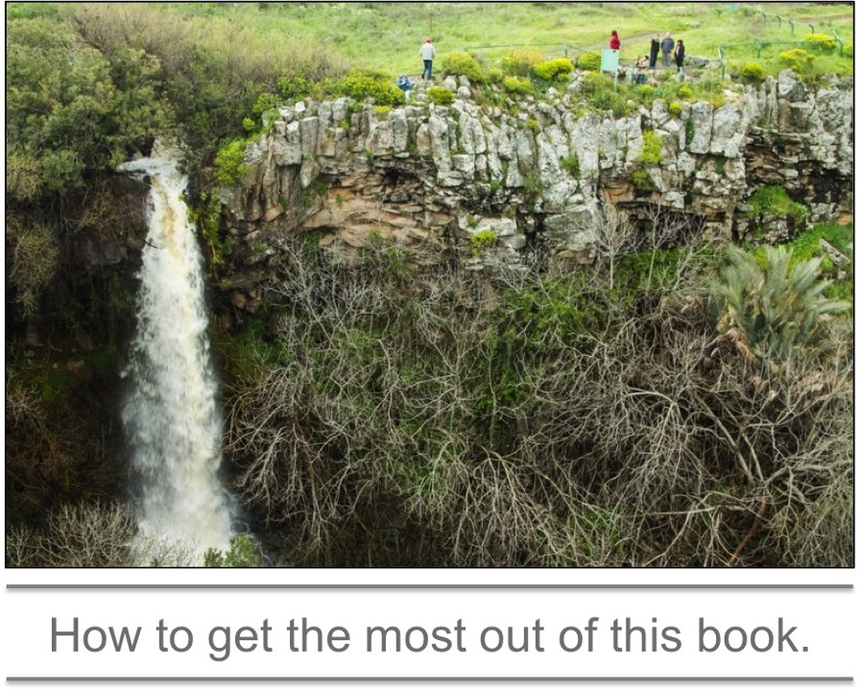
This book is designed to be a complement to the book that you should be reading every day—the Bible. Over the centuries, people have found rest for their souls by reading the Bible every day. They’ve given the book names like “God’s Word.” I am one of those who would bear witness to this incredible truth. Now that I’ve been at it long enough, God really does speak to me through the words of the Bible.
If you haven’t yet invested in the discipline of daily Bible reading, it may sound crazy that God speaks through the Bible. But in time, you’ll see. God has some great rewards for those who will spend time with Him every day by immersing themselves in his story.
So read your Bible every day. As you read this book, be sure to read the Bible passages that precede each chapter first. This is a serious request. You’ll maximize what God wants to do with the words of this book if you’ll first read the words of his book. You might even want to use your Bible to read more than simply the words printed here. Knowing the entire context of the passage is often key to understanding the passage. So don’t hesitate to read more than what’s printed inside these pages!
At the end of each chapter in this book, you’ll find a short section of application called “Make the Lesson Your Own.” Don’t skip over this. It’s extremely important. Knowledge without application is useless. Do your best to connect the line from the Bible’s message to your own life, and then follow the Bible’s instructions.
The result? Rest for your soul.

Matthew 25:1–13

At that time the kingdom of heaven will be like ten virgins who took their lamps and went out to meet the bridegroom. Five of them were foolish and five were wise. The foolish ones took their lamps but did not take any oil with them. The wise, however, took oil in jars along with their lamps. The bridegroom was a long time in coming, and they all became drowsy and fell asleep.
At midnight the cry rang out: “Here’s the bridegroom! Come out to meet him!”
Then all the virgins woke up and trimmed their lamps. The foolish ones said to the wise, “Give us some of your oil; our lamps are going out.”
“No,” they replied, “there may not be enough for both us and you. Instead, go to those who sell oil and buy some for yourselves.”
But while they were on their way to buy the oil, the bridegroom arrived. The virgins who were ready went in with him to the wedding banquet. And the door was shut.
Later the others also came. “Sir! Sir!” they said. “Open the door for us!”
But he replied, “I tell you the truth, I don’t know you.”
Therefore keep watch, because you do not know the day or the hour.

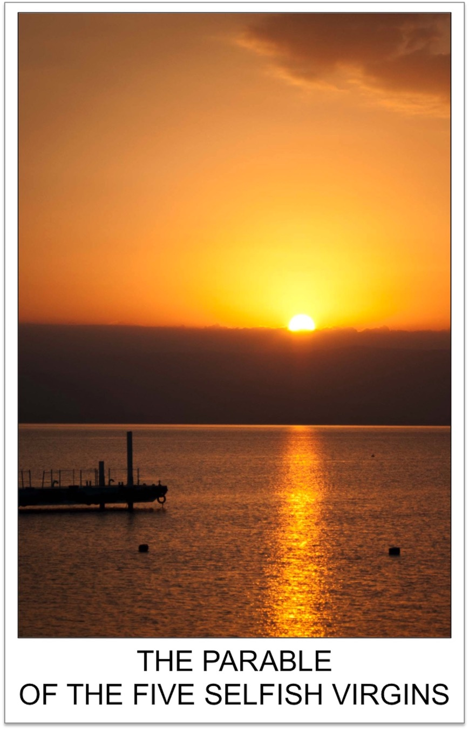
Ten virgins, Jesus said, wanted to go to a wedding.
Have you ever paid attention to young girls at a wedding? For many of them, it’s a fantasy come true. It’s the dress-up party of the year, and the bride looks like Cinderella. There’s a party and dancing and music and flowers and a dreamy groom . . .
To a young girl, it’s a setting right out of the movies.
This isn’t to say guys don’t like a good wedding, too. After all, there’s good food, good friends . . . and Cinderella to boot. Let’s face it. A wedding can be the best party you’ll ever attend.
The ten girls in Jesus’ parable had no intention of missing the party. Maybe the girls were right on the edge of their teen years. Just breaking into the world of grown-up love stories, just starting to understand the pull of one heart toward another. They really, really wanted to be a part of the wedding celebration.
But the wedding was late. With the night came darkness. Five of the girls had oil for their lamps, Jesus said, and five did not. Short end of the story? The wedding started, people joined the procession, but only those with working lamps were admitted to the evening of the year.
When this became obvious, the five girls without oil—the “unwise” virgins—begged the girls who had oil for a little fuel. If they had been around today, they would have been begging for fresh batteries for their flashlights. But in that day, it was oil for their lamps. The girls with oil said no, and told their desperate friends to go buy some. At that hour, that was an impossible task, and once the wedding was ready to start, someone shut the door. The way Jesus tells the story, there’s no doubt the door won’t be opened again, no matter what. It was a one-time opportunity, and only the five virgins with working lamps got to see Cinderella and her prince. So goes the parable of the selfish virgins.
Actually, there is no parable of the five selfish virgins. It’s just one of the uncomfortable thoughts that sticks in the back of your mind as you read of Jesus telling one of his famous stories.
The selfishness has never bothered you? Surely you’ve heard the story and wondered why Jesus didn’t just make an application about sharing. Is this the best way to live out the “Golden Rule” Jesus gave in his Sermon on the Mount? If this is the way to live out a “Do unto others as you would have them do unto you” lifestyle, we’re in for a rough life! Sharing is an admirable principle. More than that, sharing is commanded. Prophets like Isaiah (Isaiah 58:7) and Ezekiel (Ezekiel 18) put sharing squarely in the middle of what it means to be a righteous person. In their debate with Job, Job’s friends openly questioned whether or not Job had shared his possessions with others (Job 22).
No doubt about it. Sharing with others is a core value of what it means to be righteous. The concept fits in practically any sermon.
But not this time.
The reason no one listening to Jesus cried out a judgment against the five “selfish” virgins is that they knew the girls weren’t selfish at all. Let’s look at the parable from the perspective of the original audience.
If you’ve ever lived away from the city lights, perhaps you’ll understand the story better than others. It can get plenty dark at night when there are no streetlights. If you go outside at night, a good flashlight might just save your life.
There might be a snake on the ground. Poisonous or not, if you step on a snake in the dark, you’ll face an instant stress test and wish to God you’d carried a light. Or there might be nothing more than a hole in the ground that could lead to a sprained ankle. You might hear a rustling in the bushes and wonder whether you’re about to be attacked by a ferocious beast. So what if it was only a house cat? The darkness is frightening!
When the Bible speaks of itself, it says that it is a lamp to our feet (Psalm 119:105). This is the idea. There are times when just a little bit of illumination can make all the difference. It can save us time, save us stress, and even save our life.
So we carry flashlights and make sure the batteries are good. If you’re a person experienced in outdoors life, you’ll carry some extra batteries with you. You’ll change them before you’re left in the dark. You’ll have a stash of extras on a shelf at home. A flashlight needs batteries the way an oil lamp needs oil.
The word we have for people without extra batteries? Let’s just say there’s a lot of regret if your flashlight runs low and you’ve imagined a snake or two stretched out somewhere on the path ahead!
The word we have for a person who has plenty of batteries on hand is “wise.” Everyone knows flashlight batteries will eventually wear out, so a wise person will have extras on hand.
The kind of oil lamp Jesus and his audience would have known can be held in the palm of one hand. The oil jug that was its partner was just as small. It didn’t take a lot of oil to keep a lamp burning, and like all fuel, oil wasn’t cheap. People didn’t carry a lot of it. Parents didn’t let their daughters take enough to share with their friends. There may have been no more oil in an oil jug than just enough to refill a lamp one time.
But as it turns out, a single refill was just enough to get into the wedding.
There were a lot of unknowns about weddings in Jesus’ day. No one knew exactly when the wedding would be, for instance. You’d have some hints, but only when the bridegroom’s father told his son that the house he’d built for the new couple was ready could the groom go for his bride. The moment the father gave the go-ahead, the groom took off. He rallied his friends and they started a parade that wound through the village until they arrived at the bride’s home. The groom would be joined by his bride and the parade continued through the village to the location of the wedding, picking up other guests as it wound through the village. The wedding would eventually follow, and the party would last for hours.
Rules were rules, and young girls simply weren’t allowed out into the night without their lamps, and without enough oil to keep their path well lit. For five girls left in an empty, dark village? It must have been a very sad, very frightening experience.
Five girls were well-prepared and made it to the party. Five were looking for oil when they were locked out. It’s a really sad ending for five girls who, in effect, didn’t have extra batteries for their flashlights.
Five girls were wise. They weren’t selfish. They had only enough oil for themselves, and no more. It wasn’t their responsibility to supply their friends with oil. They had prepared for the wedding well, and it was their right to enjoy the party.
The key to understanding this story is the context of the conversation. Jesus wasn’t trying to get as many people as he could into a wedding. He was trying to convince people they needed to be ready for judgment! He had just warned his listeners that a day of reckoning would come “as it was in the days of Noah” (Matthew 24:37). It would, therefore, be a day with no recourse for those who weren’t prepared. And by the end of his trio of parables in Matthew 25, there was no doubt that some would be so unprepared for judgment that there would be “weeping and gnashing of teeth” (Matthew 25:30) and a departure into “eternal punishment” (Matthew 25:46).
With hell as an option, the idea of missing the party is frightening. Terrifying even. But listen to the positive spin of what Jesus was saying: Don’t go into eternity terrified of hell. Instead, do whatever it takes to be ready for the celebration of heaven! Live in such a way that it’s obvious you’ve connected with what it means to follow Jesus. Use your God-given skills for God’s glory, like the wise servants who invested their master’s money. That’s the lesson of the parable that follows the story of the ten young girls. And as the third parable of the Matthew 25 trilogy illustrates, this life will so naturally result in sharing food with the hungry, housing with the homeless, and comfort for the sick, you could separate the righteous from the unrighteous the way a shepherd separates the sheep from the goats.
So listen to Jesus as he urges us to be ready for eternity.
Like a girl getting ready for a wedding, you’ve got to be prepared.
In a very real sense, making sure you get into the best celebration any of us could ever imagine is a decision. You’ve got to think ahead and be ready.
But it’s not oil for a lamp that we need.
It’s Jesus that we need.
Deciding to follow Jesus is a decision you and you alone can make. This is the lesson of the parable. No one can make this most important of all decisions for you. In the story Jesus told, there was only enough oil for each girl wise enough to be prepared for the celebration. In this life? There’s only enough decision-making ability in you for one person. Your mother? She has only enough for her. Your dad? Same thing. Your favorite pastor? He might deliver a lot of invitations, but when it comes to heaven, he can only make the decision to go for himself. He can’t decide for any of his listeners, no matter how much he might want all of them to know the joy of eternal security.
The wedding’s coming. The invitations are out. Are you going?
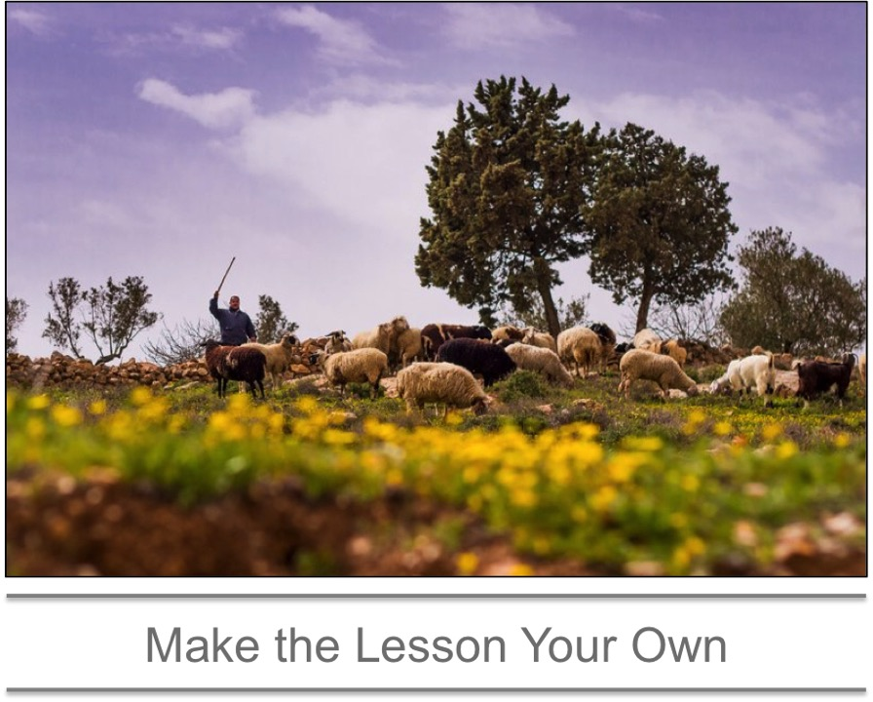
Jesus spent much of his teaching time urging people to be ready for eternity.
The story of the ten virgins is followed by a troubling story of a returning master who wants an account of how his servants had—or hadn’t—invested his resources. The final story deals with separating a mixed flock of sheep and goats in the final judgment.
You don’t want to be a goat.
The decision to follow Jesus involves a few simple steps. It may seem relatively easy to take the initial plunge of belief. However, living the faith for the rest of your life will be the biggest challenge you’ve ever known. So it’s no minor decision.
Nevertheless, these are the steps:
1. Know that God loves you.
For God so loved the world that he gave his one and only Son, that whoever believes in him shall not perish but have eternal life. (John 3:16)
2. Admit your sin to God.
For all have sinned and fall short of the glory of God. (Romans 3:23)
3. Believe that Jesus is God’s son and that he died on the cross for our sins.
While we were still sinners, Christ died for us. (Romans 5:8)
4. Tell others that you’ve decided to follow Jesus.
If you declare with your mouth, “Jesus is Lord,” and believe in your heart that God raised him from the dead, you will be saved. (Romans 10:9)
The parable of the ten young girls is about a wedding. So give a wedding some thought. Sooner or later, in every wedding someone asks, “Do you want this person as your mate for life?” And no matter how shy the bride, no matter how badly the groom stutters, all who have heard the question wait for the answer. They wait for an audible, clearly understood “Yes” or “No.”
“No” is a life-changing answer. There won’t be a marriage with a “No.” There’s no reception for a “No.” There’s no honeymoon, no family, no anniversaries with a “No.”
“Yes” is also a life-changing answer. With a “Yes,” everything changes. Two become one. A party breaks out, signaling the beginning of a great adventure. As time goes by in that great adventure, children may enter into the picture. The stories that will be retold for decades are collected year by year.
That’s what a “Yes” does at a wedding.
So Jesus has laid out the invitation. He’s the groom, and we’re the bride. He’s asked the question, and he waits for an answer. From you, from me, from everyone. This is the lesson of the oil jug: No one else can answer for you. We
each have to make the decision for ourselves.
Say “Yes.”
It changes everything.
Want to read more?
Find the Kindle edition of “Secrets from the Ancient Paths” here.
Rather have a hardback copy? You’ll find copies at experienceisraelnow.com or through the Friends of Israel.

